First, update the package and install some libraries that we need on ubuntu server 22.04.
sudo apt update && sudo apt upgrade
Install libraries that needed for our installation process from source of modsecurity 3.
sudo apt install gcc make build-essential autoconf automake libtool libcurl4-openssl-dev liblua5.3-dev libfuzzy-dev ssdeep gettext pkg-config libgeoip-dev libyajl-dev doxygen libpcre++-dev libpcre2-16-0 libpcre2-dev libpcre2-posix3 zlib1g zlib1g-dev –y
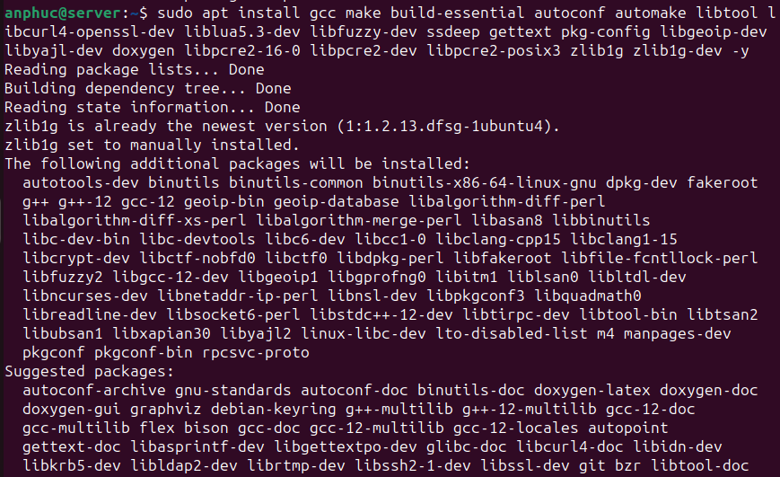

Install Modsecurity
Next, we will install modsecurity from source.
cd /opt && sudo git clone https://github.com/owasp-modsecurity/ModSecurity.git

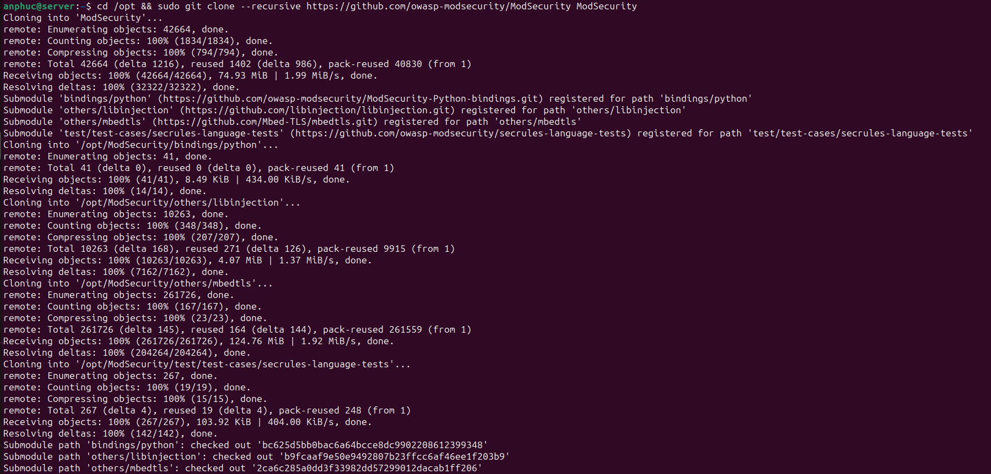

cd ModSecurity

sudo git submodule init
sudo git submodule update

sudo ./build.sh
sudo ./configure

sudo make
sudo make install

Download nginx source code
We should download source code that match version on nginx we recently installed.
cd /opt && sudo wget https://nginx.org/download/nginx-1.25.4.tar.gz
sudo tar -xzvf nginx-1.25.4.tar.gz
cd nginx-1.25.4
after we download, extract and change directory to nginx source. we build nginx with module on modsecurity that we successfully installed above.
sudo ./configure --with-compat --add-dynamic-module=/opt/ModSecurity-nginx

sudo make
sudo make modules
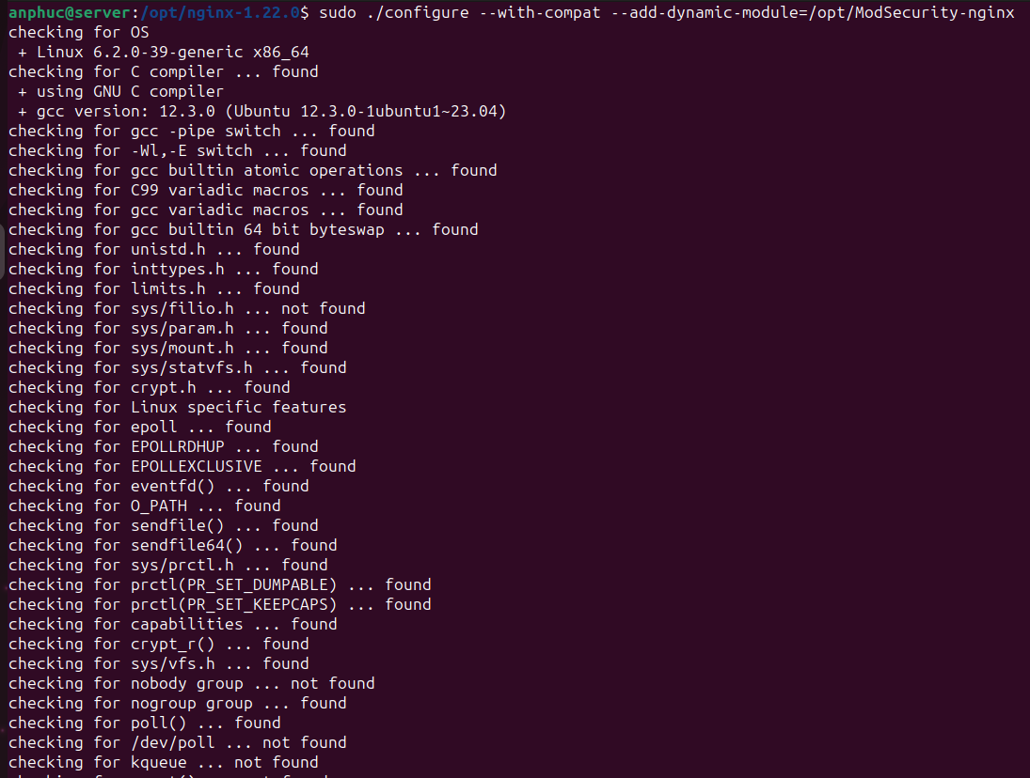
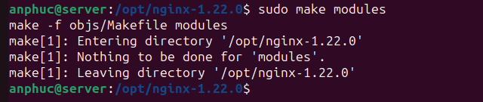
Next, we copy the modules to nginx modules-enabled, also copy configuration of modsecurity and unicode.
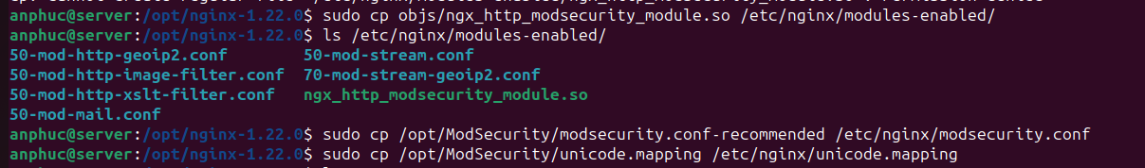
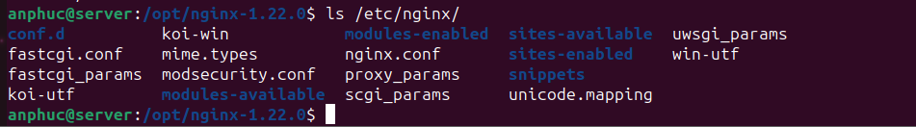
sudo cp objs/ngx_http_modsecurity_module.so /etc/nginx/modules-enabled/

sudo cp /opt/ModSecurity/modsecurity.conf-recommended /etc/nginx/modsecurity.conf

sudo cp /opt/ModSecurity/unicode.mapping /etc/nginx/unicode.mapping

Enable ModSecurity in nginx.conf
Next, we edit configuration of nginx to load module of modsecurity
sudo nano /etc/nginx/nginx.conf
add this line to main configuration.
load_module /etc/nginx/modules-enabled/ngx_http_modsecurity_module.so;
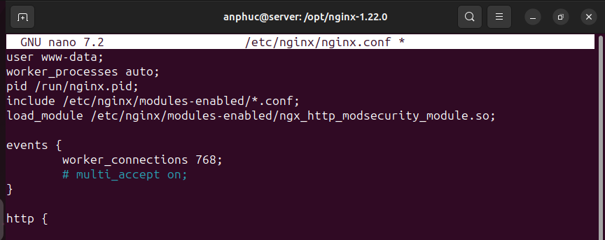
then, we also need to modify the server block to activate modsecurity.
sudo nano /etc/nginx/sites-enabled/default
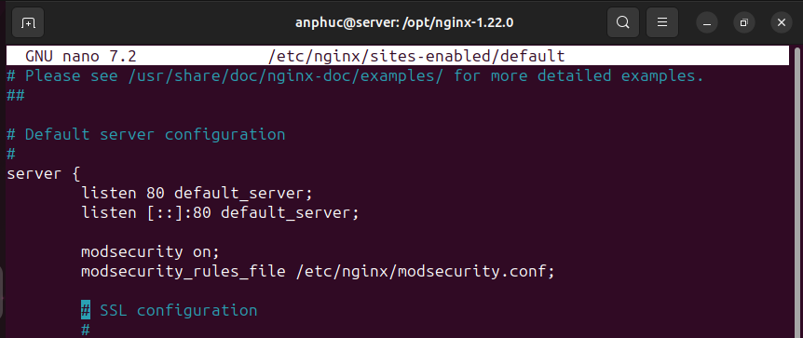
modsecurity on;
modsecurity_rules_file /etc/nginx/modsecurity.conf;

and also, edit /etc/nginx/modsecurity.conf to change SecRuleEngine to On.
sudo nano /etc/nginx/modsecurity.conf
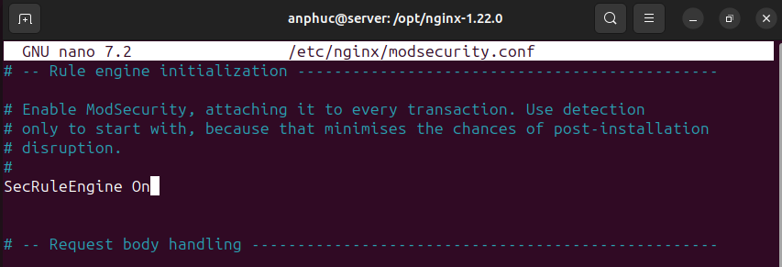
SecRuleEngine On
after that we can our nginx configuration and restart nginx server
sudo nginx -t
sudo systemctl restart nginx
We can test the nginx server with browser on its public ip address.
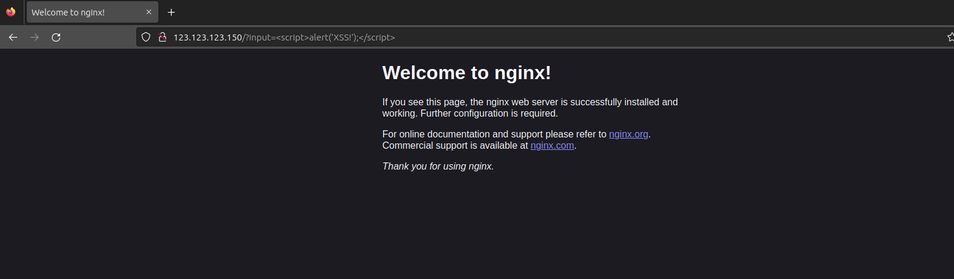
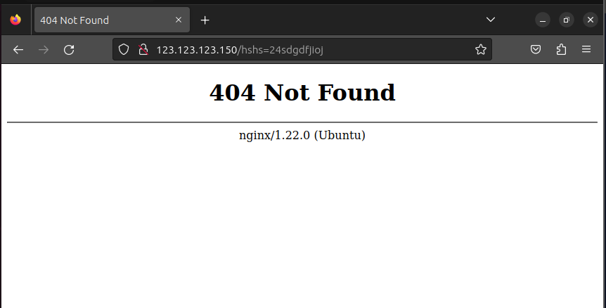
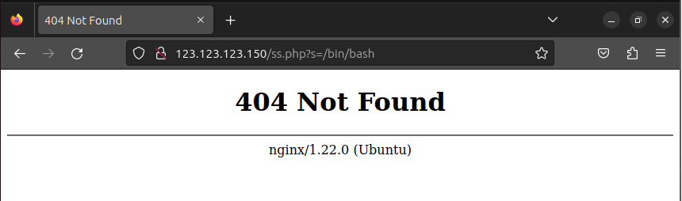
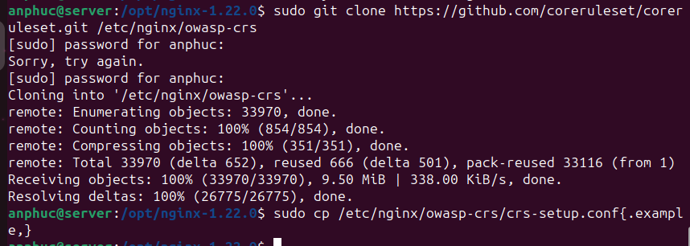
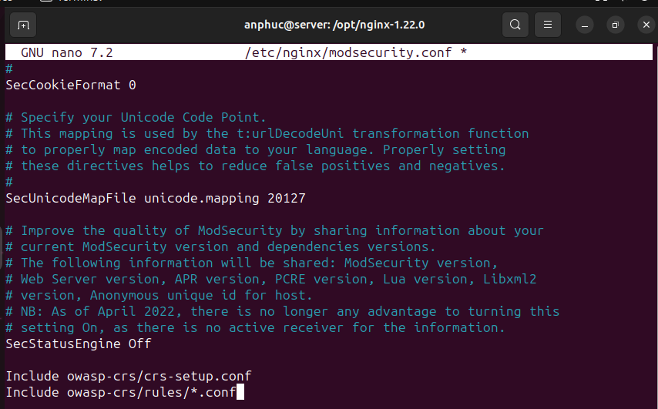
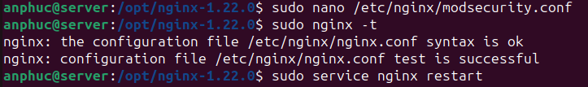
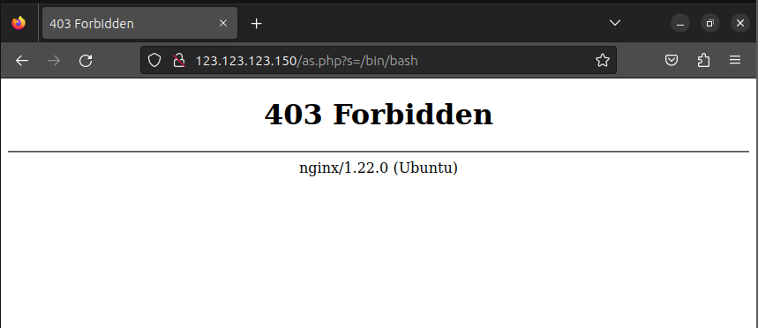
sudo tail -f /var/log/modsec_audit.log
sudo tail -f /var/log/nginx/error.log
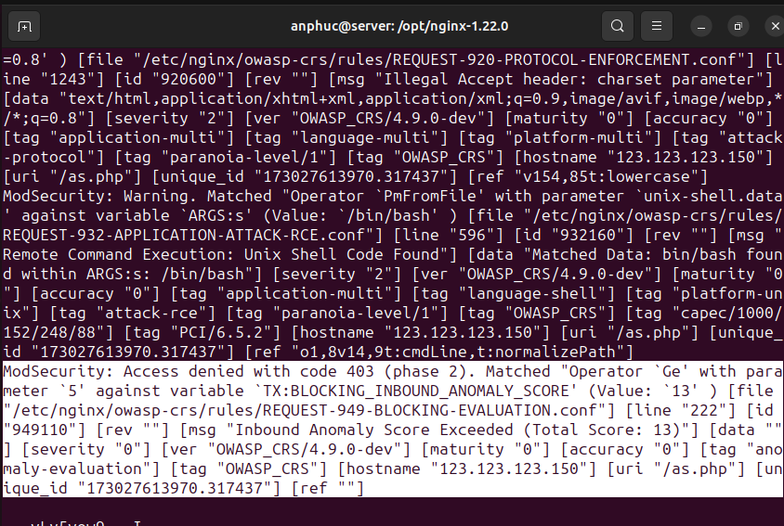
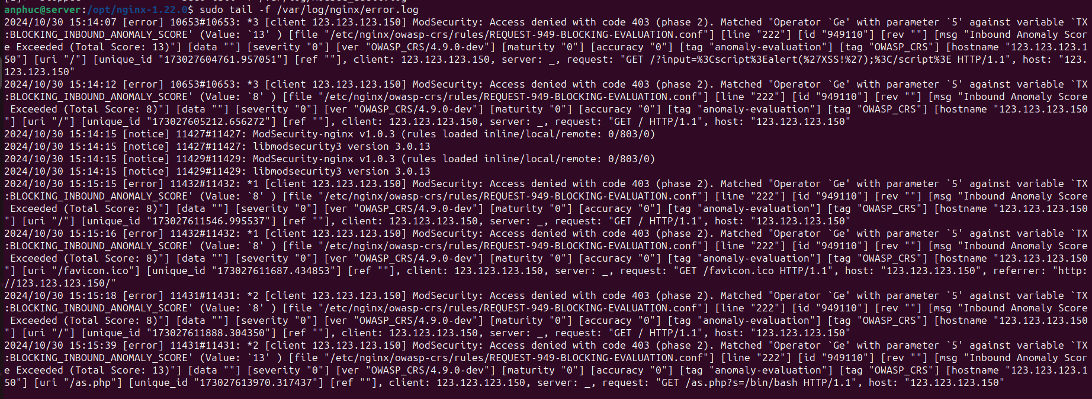

Update Rule with CORE RULE SET (CRS)
Now, we need to download core rule set from owasp, owasp crs provide rule to check if the client request has malicious code or not.
We directly download owasp crs to nginx configuration directory.
sudo git clone https://github.com/coreruleset/coreruleset.git /etc/nginx/owasp-crs
then we copy the configuration.
sudo cp /etc/nginx/owasp-crs/crs-setup.conf{.example,}
and we need to update our modsecurity configuration to load owasp crs.
sudo nano /etc/nginx/modsecurity.conf

